BASIC RULES AND REGULATIONS IN FOOTBALL
Football is known as „a beautifull game”. It is player world over and followed passionately a well. It Has become a game that involves so much emotions and seriousness as it a game loved by al most everyone in this world. The basics of the game are pretty simple:
- 11 players representing a nation or respective clubs play against another,
- a match is held typically for 90 minutes. Half time begins at 45 minutes where teames take a break,
- the game begins with the toss of a coin, and the winning captain decides which goal to defend or to take the first kick off,
- all players must use their feet head or chest to play the ball- only the goalkeeper is allowed to use their hands, and only within their designated goal area,
- the aim of the game is to score a goal, which is achieved by kicking or heading the ball into the opposition team's goal,
- if the ball touches or crosses the side line, it is thrown back in by the team that was not the last to touch the Ball,
- the game is controlled by a central referee, and two linesmen. They award free kicks and penalties when rules are broken. For continual breaking of rules or for a bad foul, the player may be sent off.

FIELD OF PLAY
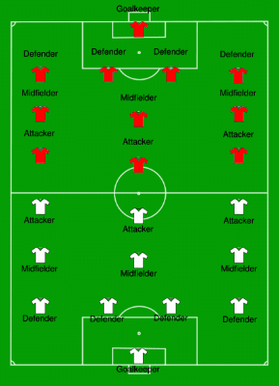

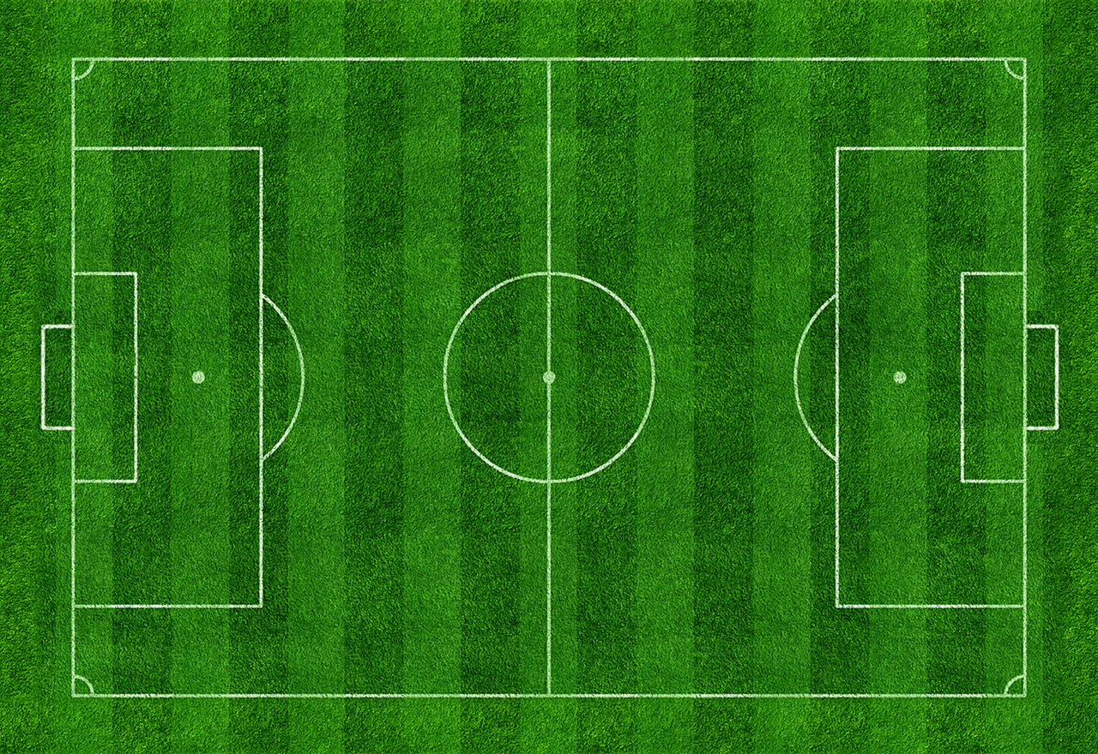

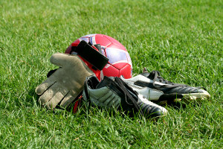
The ball used in the game of football should be spherical, with a circumference ranging from 68 cm to 70 cm. The weight of the ball used should be within 410 g to 450 g, and it can be made of leather or any other material.

The basic equipment compulsory for every player includes, a jersey, shorts, socks, shin guards, and shoes.

